**Simple piano with raspberry pi3**

* Summary

Making a simple piano with three main functions:

(1) Free playing in any rhythm.

(2) Recording the rhythm and singing it again by itself.

(3) Singing random songs that had been prepared.

* Step 1 Getting Ready
  1. Raspberry Pi3 *1
  2. microSD card for Raspberry pi3
  3. Breadboard *1
  4. Piezo Buzzer *1
  5. Male to female jumper wires*(8+8+2+7+1+2)
  6. Button*(8+2)
  7. LED *8
  8. Resistor * (8+8+4)
  9. Seven-segment display *1
  10. Power supply
* Step 2 Wiring

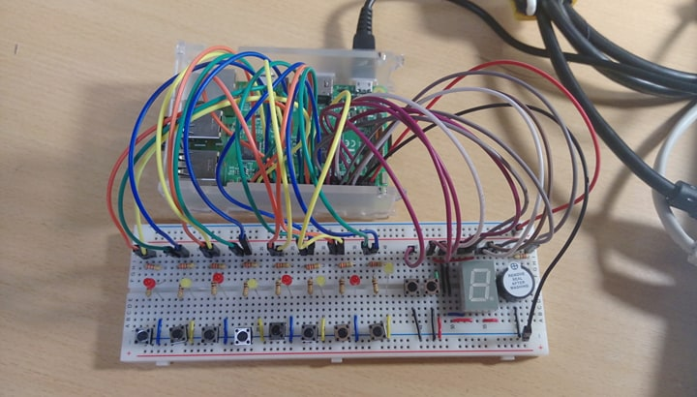

* Step 3: Set up Raspberry Pi3
  1. By document - Setup Raspberry Pi3
* Step 4: Coding by Python

1. File – Piano_fin.py
2. Prepared songs’ files – 1.txt to 5.txt (at most can be 10 files)

* Step 5: Testing
* Step 6: Enjoy the piano!!
  1. Demo video - <https://www.youtube.com/watch?v=cE4Nc_Swugk>